Building and engaging the Focus Bear Community
The proposed strategies are designed to be viable and sustainable in the long term, aligned with Focus Bear’s realistic approach, prioritizing quality interaction over reach and content volume.
As a first step, Focus Bear’s focus should not be on becoming viral or trending. To achieve that kind of visibility in the future, the company must first concentrate on building trust in order to establish strong positioning. In this way, it can create conversion networks of followers who remain consistently interested in Focus Bear and build a solid community base.
This is especially important when working with individuals with ADHD, autism, and other neurodivergent profiles. Engagement with this audience is not achieved through “hard power” or exaggerated marketing tactics, but through a more committed, respectful, and balanced approach.
Proposed Strategies
Strategy 1: Transparency mode
This strategy is based on Focus Bear sharing, in an organized and selective way, certain aspects of the app’s internal processes through social media. The audience can learn more about the reasoning behind design decisions, improvements during testing phases, or “beta” stages. Focus Bear can consult users’ preferences and gather feedback before launching new updates.
For example, creating small interactive polls in content:
“We’re improving reminders. What would help you the most?”
- More visual reminders
- Custom vibration settings
- Customizable reminder text
- Customizable reminder colors
It is also recommended to explain why changes are being made in order to communicate clarity, logic, and warmth — showing that user recommendations are being heard. This helps highlight improvements and reinforces the message that new features are created or enhanced thanks to community feedback.

Strategy 2: Real minds

Create a permanent section where users can honestly share their experiences of living with a neurodivergent brain. This can be anonymous or public, depending on user preference. The focus should not only be on achievements but also on obstacles, overwhelming processes, strategies that did not work, and approaches that did help — which could benefit others with ADHD or neurodivergence.
The format should be clear and concise. It could be a short written post within the app or a short-form video. The goal is to communicate authenticity, not perfection, showing humanity so users feel identified rather than excluded. It may also support individuals who struggle with procrastination.
Initially, these posts could be shared on platforms such as TikTok, Instagram, and YouTube, and in the future integrated into a dedicated in-app community section.

Strategy 3: Redefining productivity beyond task completion
Focus Bear emphasizes productivity, minimizing distractions, and increasing efficiency. However, it should also promote empathetic messaging toward neurodivergent minds, as many individuals feel overwhelmed by the pressure of hyper-productivity.
Focus Bear can promote a balanced and sustainable approach, reinforcing that productivity is not about doing more, but about managing responsibilities in a sustainable way.
Unlike competitors that promote exaggerated constant performance, long task lists, and relentless output, such messaging can create guilt, overload, stress, and even health issues for individuals with ADHD and neurodivergence.
This strategy can be applied through content such as motivational but realistic phrases, for example:
“If today you only completed one important task, that counts.”
Interactive post ideas according to the strategies

Strategy 1: Transparency mode
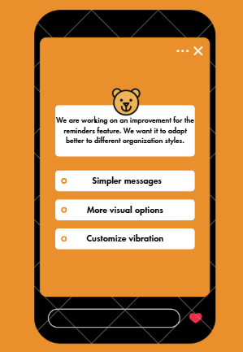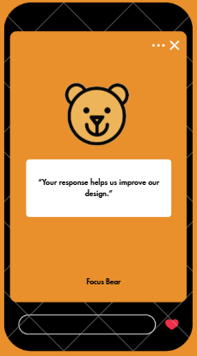

Strategy 2: Real minds
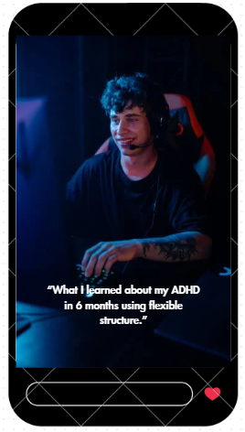
Strategy 3: Redefining productivity beyond task completion
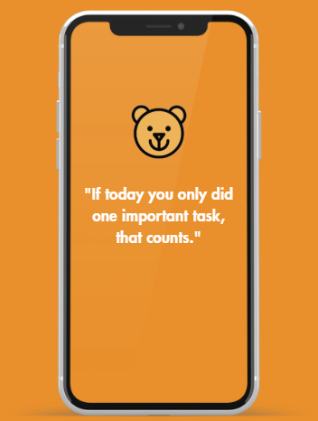

Examples of Responses to Comments

1. Comment: “I love that you talk about resting without guilt. It’s exactly what I needed to read!”

Example response:
Thank you for sharing that 💛 We truly believe that rest is also progress. At Focus Bear, we promote sustainable productivity, not constant burnout. If today you structured your rest, you already did something valuable.

2. Comment: “Do you diagnose ADHD or autism?”

Example response:
Thank you for your question ✨
Focus Bear does not provide medical diagnoses. What we do offer are structure tools, guidance, and initial orientation to help individuals better understand their needs and, if they choose, seek professional support. Our approach is to facilitate, not replace specialists.

3. Comment: “This doesn’t work for everyone. Not all of us can just ‘rest.’”

Example response:
Thank you for pointing that out 🙏 You’re right — not every strategy works the same for everyone. That’s why we aim to build a community where different experiences can be shared. If you’d like to tell us what has worked for you (or what hasn’t), we’d love to hear it.

4. Comment: “If you need an app to organize yourself, the problem is you.”

Example response:
Everyone manages their time and energy differently. Some people prefer physical planners, others prefer digital support. Our goal is to offer an additional tool — not to impose a single way of organizing life.

Reusable Response Template for Private Messages (DM)
General Inquiries

To | User 1
Cc
Cco
Subjet | Follow-up to provide you with a response
Hello, User 1
Thank you for reaching out and for sharing your question with us.
At Focus Bear, we aim to support neurodivergent individuals, including those with ADHD and autism, by promoting sustainable productivity that respects individual rhythms and needs.
Please note that we do not provide medical diagnoses or replace professional support. Our goal is to offer practical tools for structure, focus, and habit-building that can complement other forms of support.
If you’d like, feel free to share a bit more about what you’re looking for, and we’ll gladly guide you on how our platform might fit your needs.
We’re here to help.

Template for High Volume of Messages:
“Hello, thank you for reaching out.

Focus Bear provides organization and focus tools, especially designed with neurodivergent individuals in mind. We do not provide medical diagnoses, but we’re happy to guide you on how to use the platform based on your needs.

Let us know what you’re looking for, and we’ll be glad to help.”
Message for Sensitive Questions or Comments:
“Hello,

Thank you for trusting us with this.

While Focus Bear does not replace medical or psychological support, it can serve as a complementary tool for organizing tasks and building sustainable routines. If you feel you need professional guidance, we encourage seeking support from a qualified specialist.

If you’d like, we can walk you through how our features may support your current situation.”

